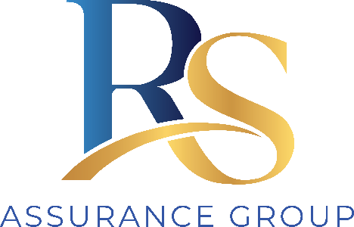
RS Assurance Group
Code of Conduct
for Workers

The behaviour expected of every person who works for RS Assurance Group, aligned to the NDIS Code of Conduct.
Document ID | POL-COC-001
Version | 1.0
Prepared by | Ainim Support Services
Prepared for | RS Assurance Group
Applies to | All staff, contractors, students and volunteers
Approved by | [Name, Position]
Date | [DD/MM/YYYY]

Purpose
This Code sets the standard of behaviour RS Assurance Group requires of everyone who works with or around participants. It reflects the NDIS Code of Conduct, which binds both the provider and its workers, and applies at all times while representing RS Assurance Group.
A breach of this Code is taken seriously and may lead to disciplinary action, termination, notification to the NDIS Quality and Safeguards Commission, and referral to police where a crime may have occurred.

The seven obligations
Every worker must uphold each of the following.

1. Respect individual rights to freedom of expression, self-determination and decision-making
- Support participants to make their own decisions and to direct their own supports.
- Give balanced information so choices are informed, and respect the choice even where you would choose differently.
- Never coerce, pressure or make decisions for a participant that are theirs to make.

2. Respect the privacy of people with disability
- Collect, use and share personal information only as needed and as consented to or required by law.
- Keep information secure and do not discuss participants outside your role.
- Deliver personal or private supports discreetly and as the participant prefers.

3. Provide supports safely and competently, with care and skill
- Work only within your training, role and authority; ask when unsure.
- Follow support plans, procedures and reasonable instructions, and keep your skills current.
- Never work while impaired, and never take shortcuts that put a participant at risk.

4. Act with integrity, honesty and transparency
- Be truthful in records, claims and communication; never falsify a document or a timesheet.
- Never use a participant's money or property for anything that is not for that participant, and never borrow from or lend to a participant (see POL-MP-001).
- Disclose any conflict of interest, and decline gifts, tips or inducements.

5. Raise and act on concerns about quality and safety
- Report concerns about a participant's safety or the quality of supports promptly — including concerns about a colleague, a family member or another provider.
- Know how to report an incident and how a participant makes a complaint.
- Understand that reporting in good faith is expected and protected.

6. Prevent and respond to violence, exploitation, neglect and abuse
- Take active steps to keep participants safe from harm, including financial exploitation and neglect.
- Act immediately to protect a participant, and report to your supervisor and, where required, the NDIS Commission.
- Believe and support a participant who discloses harm.

7. Prevent and respond to sexual misconduct
- Maintain professional boundaries at all times; never engage in sexual or inappropriate conduct with a participant.
- Report any sexual misconduct immediately.
- Never groom, isolate or exploit a participant.
Contacts
- RS Assurance Group supervisor / manager: [name, phone]
- NDIS Quality and Safeguards Commission: 1800 035 544 | ndiscommission.gov.au
- Police (emergency / non-emergency): 000 / 131 444

Worker acknowledgement
To be signed at induction and at each annual refresher, and kept on the worker's file.
I have read and understood the RS Assurance Group Code of Conduct. I understand it reflects the NDIS Code of Conduct, that it applies to me at all times while representing RS Assurance Group, and that a breach may lead to disciplinary action, notification to the NDIS Commission, and referral to police.

Worker name (printed)

Worker signature Date

Supervisor name and signature Date

